**Classic BADI Definition**

1. Go to tcode SE18.Give a BADI name starting with Z/X. Go to Utilities->Create Classic BADI.

(Do not click create)

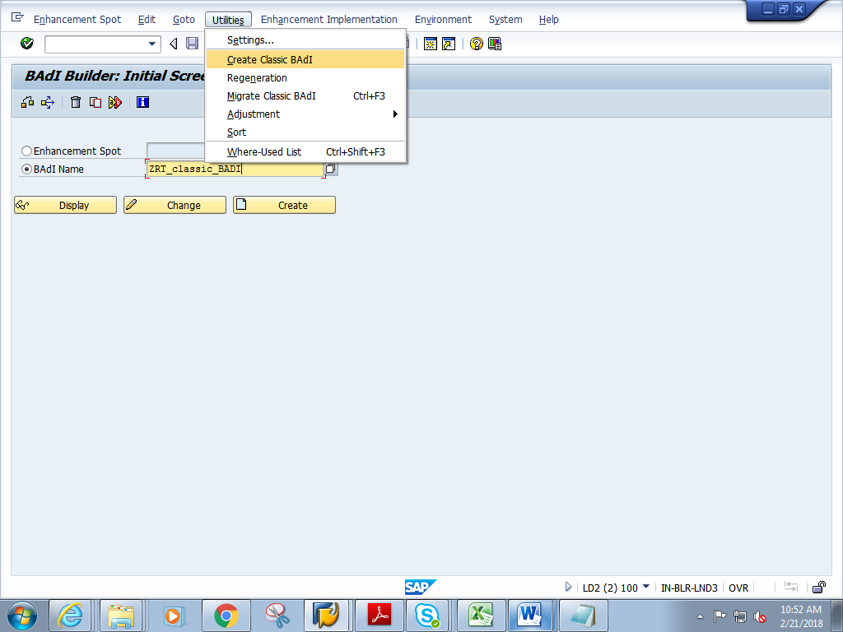

1. Give a short description. Double click on the Interface name

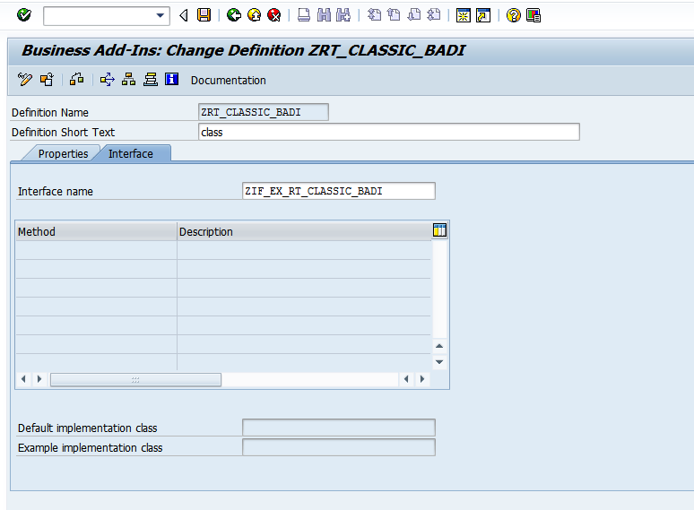

1. In the interface, add the method METH_FLIGHT as shown below. Click on Parameters

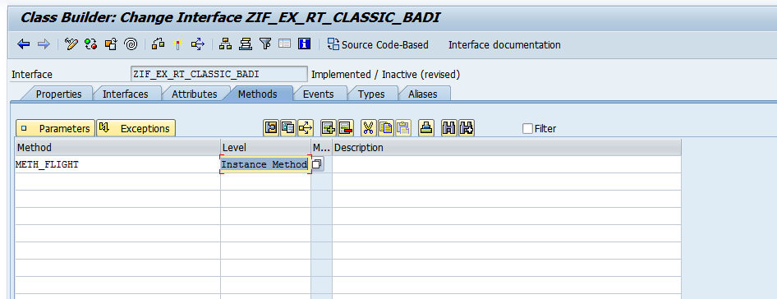

1. Give 2 parameters I_CARRID and E_SFLIGHT

(Note : ZBADI_SFLI is a table type of line type SFLIGHT)

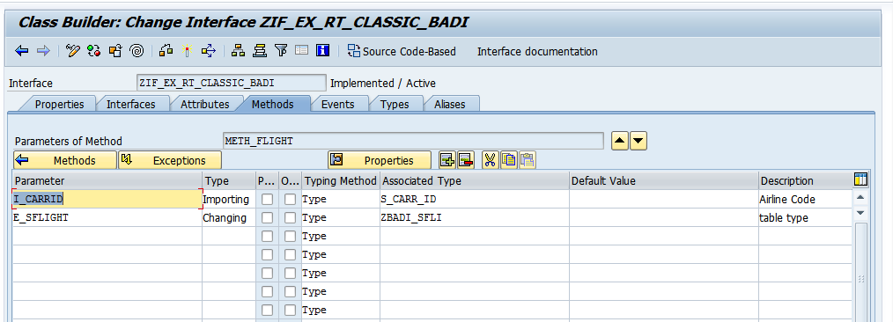

Table type :ZBADI_SFLI

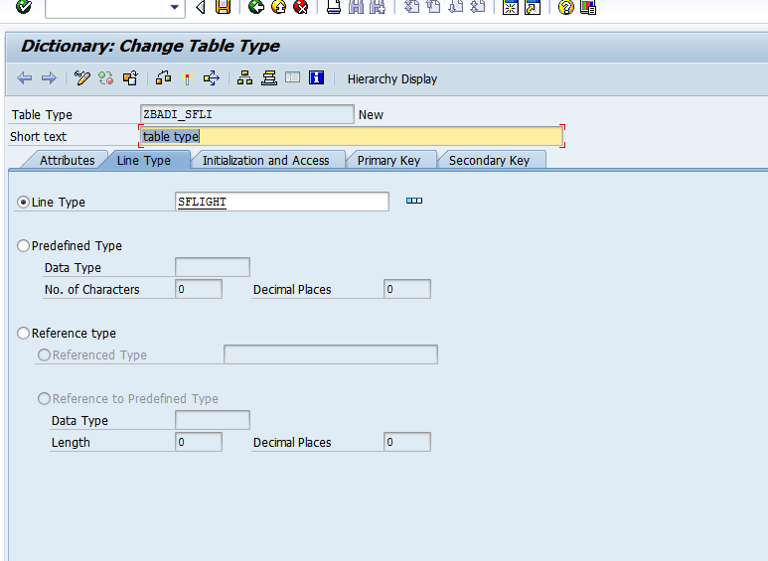

1. Save and activate the BADI

